**DAILY ONLINE ACTIVITIES SUMMARY**

|  |  |  |  |  |  |  |  |  |
| --- | --- | --- | --- | --- | --- | --- | --- | --- |
| **Date:** | **27-06-2020** | | | | | **Name:** | **D Jasmine Joyline** | |
| **Sem & Sec** | **VI Sem A** | | | | | **USN:** | **4AL17CS024** | |
| **Online Test Summary** | | | | | | | | |
| **Subject** | | **-** | | | | | | |
| **Max. Marks** | | **-** | | **Score** | | | **-** | |
| **Pre-placement Training Summary** | | | | | | | | |
| **Course** | 1.DBMS2. JAVA AND J2EE | | | | | | | |
| **Certificate Provider** | | | **-** | | **Duration** | | | **4hr** |
| **Coding Challenges** | | | | | | | | |
| **Problem Statement:**  Write a Java Program to count the number of words in a string using HashMap. | | | | | | | | |
| **Status:Completed** | | | | | | | | |
| **Uploaded the report in Github** | | | | | **Yes** | | | |
| **If yes Repository name** | | | | | <https://github.com/alvas-education-foundation/D_Jasmine_Joyline/tree/master/daily_progress> | | | |
| **Uploaded the report in slack** | | | | | **Yes** | | | |

Online Test Details:

-

Online Training Details:

Attended class on the topic DBMS from 9am to 11am

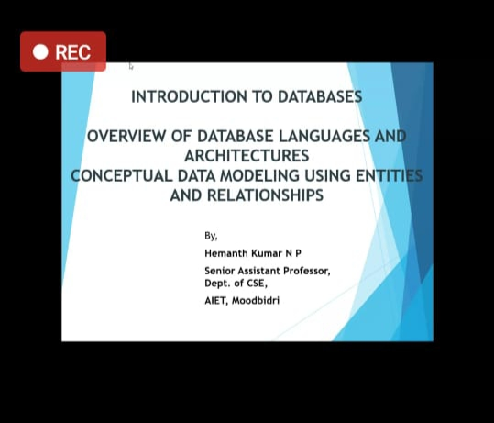

Attended class on the topic Networks and Cyber Security from 11am to 1:30pm

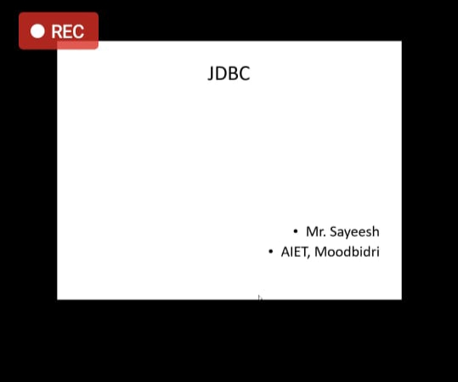

Coding Challenges Details:

Write a Java Program to count the number of words in a string using HashMap.

This is a collection class program where we have used HashMap for storing the string.

First of all, we have declared our string variable called str. Then we have used split() function delimited by single space so that we can split multiple words in a string.

Thereafter, we have declared HashMap and iterated using for loop. Inside for loop, we have an if-else statement in which wherever at a particular position, the map contains a key, we set the counter at that position and add the object to the map.

Each time, the counter is incremented by 1. Else, the counter is set to 1.

Finally, we are printing the HashMap.

